

CUKUROVA UNIVERSITY ELECTRICAL AND ELECTRONICS ENGINEERING

EEE 221 ELECTRICAL CIRCUITS LAB I

STUDENT

NAME-SURNAME:

ID:
EXPERIMENT 1

RESISTORS

Aim:
To determine the equivalent resistance of a circuit using colour code and to verify it using a multimeter

Equipments:
- Resistors
- Multimeter

Preliminary Work:
Assume that the resistor values at Figure 2.6 are R1 = R2 = 2.2 kΩ, R3 = 1k Ω and R4
= R5 = 1k Ω. Calculate the equivalent resistance between the terminals A and B.

Explanation:

Resistors:
Resistors are cylindrical shaped components with leads at either end. The resistance in ohms (Ω) associated with the resistor is specified by a color code (see Table 1.1) in the form of bands painted on the body of the resistor
- The first band is located nearest the end of the resistor, and specifies the first significant digit of the resistance.
- The second band specifies the second significant digit.
- The third band tells the power of the ten by which the two-digit number is multiplied to obtain the resistor value.
- The fourth band indicates the tolerance.

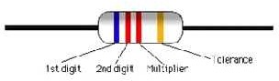

Figure 2.1: Resistor with four colour bands

Table 2.1: Resistor Color Codes

First Band |  | Second Band |  | Third Band |  | Fourth Band
Color | Digit | Color | Digit | Color | Multiplier | Color | Tolerance
Black | 0 | Black | 0 | Black | 1 | Violet | 0.1%
Brown | 1 | Brown | 1 | Brown | 10 | Blue | 0.25%
Red | 2 | Red | 2 | Red | 100 | Green | 0.5%
Orange | 3 | Orange | 3 | Orange | 1000 | Brown | 1%
Yellow | 4 | Yellow | 4 | Yellow | 10000 | Red | 2%
Green | 5 | Green | 5 | Green | 100000 | Gold | 5%
Blue | 6 | Blue | 6 | Blue | 1000000 | Silver | 10%
Violet | 7 | Violet | 7 | Silver | 0.01 | No Band | 20%
Grey | 8 | Grey | 8 | Gold | 0.1
White | 9 | White | 9

Potentiometer:
A potentiometer (sometimes called a “pot”) consists of a variable contact along a fixed resistance:
A device similar to a small spoon wipes across a surface coated in conductive carbon. This the centre contact of the pot. The outer contacts are attached to the ends of the conductive surface.
Those with the large blue protoboards may notice some black “slide” pots mounted on the frame.
Both of these devices are the type you would see used to control music volume on consumer electronics.

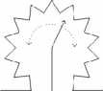
or

Figure 2.2: Symbols fort the potentiometer

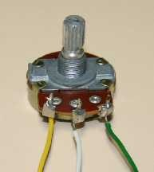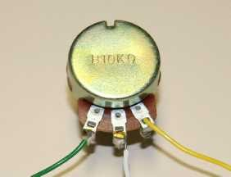
  - (b)
Figure 2.3: (a) Top view of potentiometer and (b) bottom view showing the value and type.

The pot shown in Figure 2.3 is a “B” or linear type, with a value of 10 k ohms. This can be used in two ways:
- As a voltage divider: We use the variable contact (or armature) to provide a fixed fraction of the voltage across the whole resistor (eg. in a radio volume control).
Connect up the following circuit, and set V1 to 1V (25% of Vs)

Vary Vs between 1V, 2V, 3V, 4V and 5V and measure V1 as a percentage.
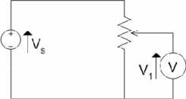
Figure 2.4: A simple voltage divider circuit designed with a potentiometer.

- As a variable resistor: We connect between one end and the variable contact to give a variable resistance. Connect up the following circuit and change the potentiometer and observe the change in brightness of the LED.
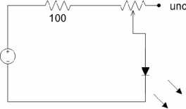
Figure 2.5: Usage of the potentiometer as a variable resistor.

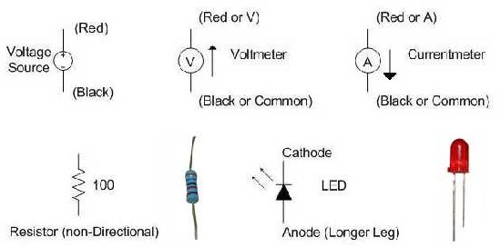

Figure 1.1. Symbols and pictures

Multimeter
What you see in Figures 1.2 – 1.4 is a multimeter, which has its measuring leads and selector arranged to measure different electrical signals. The “ohm meter” is just the multimeter wired up to measure resistance in ohms. A short circuit is usually zero ohms, but could read up to 2 ohms due to resistance in the measuring leads. An open circuit is usually hundreds or thousands of millions of ohms. This is usually displayed as “1.” followed by blank digits or “OL”, which stands for overload.
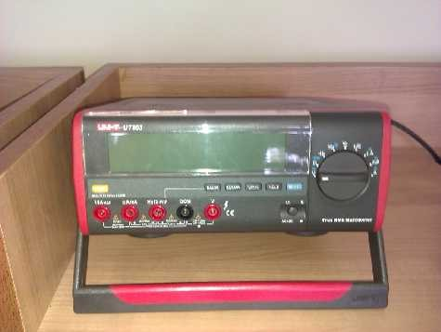
Figure 1.2. Multimeter

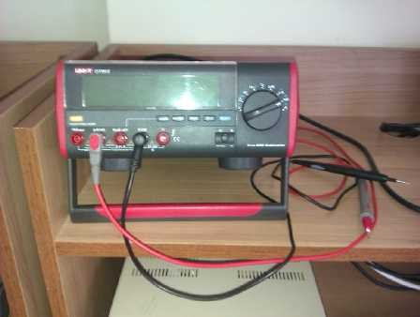

Figure 1.3. Multimeter wired for Current

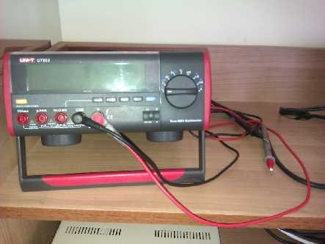
Figure 1.4. Multimeter wired for DC Volts

Prototyping board
The small holes in the board allow electrical connection to wires and component leads. Some of these holes are connected together, so use patch leads to connect between desired “nodes”. For convention and ease of interpretation the paired rows at the top and bottom of the board are used for power rails and ground. Note that they may not be continuous across all protoboards .

Note that the coloured posts around the protoboard are not connected to it until YOU join them with patch wires. If you look at the picture below, the top horizontal holes are highlighted with different colours. All the pink holes are joined together in groups of 25, under the board, as are the green ones, but the green and pink holes aren’t joined unless YOU join them with wires. The purple vertical holes are joined in groups of 5 but they are not connected to their neighbouring columns, or the horizontal rows until YOU join them.

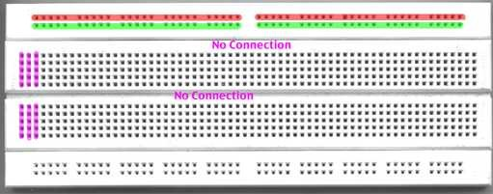

Figure 1.5. Detail of white proto board

The pictures here show see-through views of various protoboards. The top picture shows horizontal connections all the way across the board. SOME BOARDS HAVE A BREAK IN THE MIDDLE, so beware. The bottom right part of Figure 1.6 shows the metal strips that are behind each group of holes. These strips are like pegs which hold the wires in place and they can hold 5 or 25 wires.

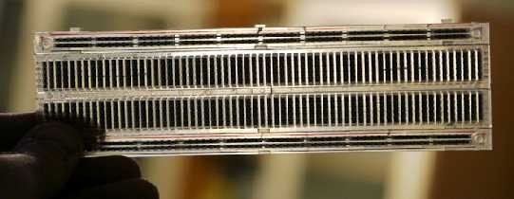

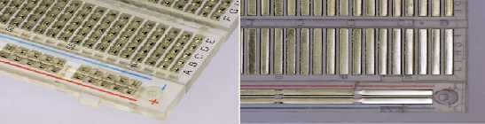

Figure 1.6. View of insides of proto boards

Lab Utilitys

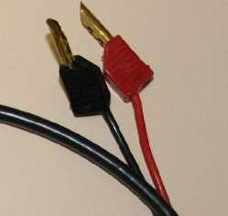

(a) (b)

Figure 1.7. (a) Banana plugs and (b) Pliers and wire strippers

Power supply

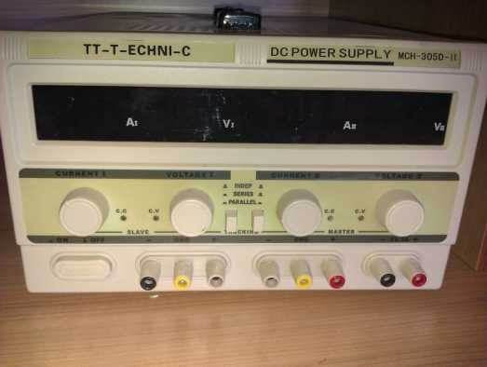

Figure 1.8. Laboratory power supply

In Figure 1.8, you can see controls for current and voltage. At the very bottom-right of the power supply is a fixed 5VDC output, limited to 3 amps maximum output.
There are also two variable-output connections with 3 terminal posts. These have a maximum output of 32 Volts DC. The right-hand side of these two has been setup for 10 Volts DC and the cables would be plugged in to the black and red terminal posts just below the words “Tracking” and “Master”.
Tracking: You can see some buttons below the words “Indep.”, “Series” and “Parallel”. These allow the two different variable sections to be used in different ways.
Independent: The output voltages and current are unrelated to each other, so one output could be 7.5 volts, while the other is 24 volts.
Series: This allows either a higher voltage than 32 V, or to treat the system as having a positive and negative voltage rail of up to 30 V, i.e. + and – 15 volts. The black terminal of the left output will be the negative voltage rail. The black terminal of the right output will be the zero volts rail, and the red terminal of the right output will be the positive rail.
Parallel: This combination allows more than 3 amps to be supplied to a circuit, so the power supply can deliver the same voltage on each of the outputs, but up to 6 amps maximum.

Circuits on a breadboard:

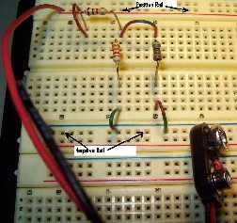
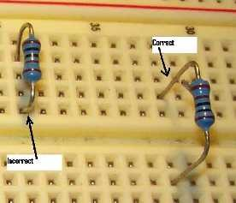
(a) (b)
Figure 1.9. (a) Example layout of protoboard.and (b) Placement of components in protoboard

The figures above show how to layout the components on the protoboard.

Figure 1.9(b) shows the incorrect placement of a component on the left. The resistor is shorted by the segment as all 5 of the holes in the segment are at the same voltage.
The resistor on the right spans the gutter, which insulates the two segments. Thus the resistor on the right can have different potentials on each leg.

Experimental Procedure

Resistor:
R₁
R₄
A
R₃
B
R
R₂
R₅
R₁
R₃
R₄
R
2
Figure 2.6: Circuit diagram of experiment 2.

  - Take 5 different resistances. Note down the colours of the bands on these resistances to the Table 2.2.
  - Using Table 2.1 determine the values of these resistances and fill in the Table 2.2.
  - Measure the values of these resistances using a multimeter and fill in the Table 2.2.
  - Mount the circuit as shown in Figure 2.6 on the bread board.
  - Determine the equivalent resistance of the circuit between terminals A and B theoretically and verify using a multimeter.

Table 2.2: Measured and calculated resistor values.

Resistance | Colour Code | Calculated Value | Measured Value
R1
R2
R3
R4
R5

Potentiometer:
In this part of the experiment connect the circuit shown in Figure 2.5 and observe how the brightness of the LED is changing due to the change in value of the potentiometer.

EXPERIMENT 2

CIRCUITS, METERS AND MEASUREMENTS

Aim:
To understand:

- Simple measurements
- Basic voltage and current laws
- Measurement errors

Equipments:

- Adjustable Power Supply
- Two or three multimeters (measure current, voltage, resistance)
- Prototyping Board
- Patch Wires with banana plug connections
- Patch Leads
- Components:
  - Resistors: 100 ohm, 120, 1K, 3.3K, 4.7K, 10M (x 3)
  - LED (Light Emitting Diode) – any colour

Explanation:

We will use the terms breadboard, protoboard, prototyping board interchangeably. A circuit consists of one or more components arranged with some power source and possible load devices. Then we can measure voltage, current or resistance with appropriate connections. If you’re not familiar with the terms, ask your tutor/s about them.
On the following couple of pages you will see pictures and some explanations of the equipment you will use

Preliminary Work:

- Calculate the voltages on the resistors in Figure 1.10. Use the given values in Table
  - for source voltage and resistors values.

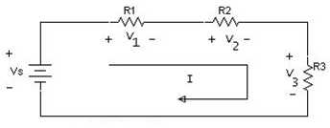
Figure 1.10. Serial Circuit

- Calculate the currents and voltages on the resistors in Figure 1.11 and fill in the Table
1.2. Assume that the source current is 21 mA.
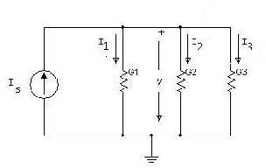

Experimental Procedure:
Figure 1.11. Parallel Circuit

- Construct the circuit in Figure.10, measure each voltage drop and loop current. Fill in the Table 1.1. Compare the results obtained from the calculations and measurements.
- Construct the circuit in Figure 11. Change the voltage of the power supply to obtain a 21 mA current on the main branch of the circuit. Then measure each branch current and node voltage. Fill in the Table 1.2. Compare the results obtained from the calculations and measurements.

Table 1.1: Calculation and Measurement results for the serial circuit.

R | V_{S} | VOLTAGES DROP |  |  |  |  |  | LOOP CURRENT
R | V_{S} | CALCULATED |  |  | MEASURED |  |  | CAL. | MEA.
R | V_{S} | V1 | V2 | V3 | V1 | V2 | V3 | CAL. | MEA.
R1=1KΩ R2=1KΩ R3=10KΩ | 6V
R1=1KΩ R2=1KΩ R3=10KΩ | 8V
R1=1KΩ R2=1KΩ R3=10KΩ | 10V
R1=1KΩ R2=1KΩ R3=10KΩ | 12V

Table 1.2: Calculation and Measurement results for the parallel circuit

 | UNKNOWN VOLTAGES |  |  | LOOP CURRENTS
 | V1 | V2 | V3 | I | II | III
Calculated
Measured

END OF EXPERIMENT

EXPERIMENT 3

VOLTAGE and CURRENT DIVIDERS

Aim:
To experimentally verify the current divider rule (CDR) for parallel circuits and the voltage divider rule for series circuits.

Equipments:
- Adjustable Power Supply
- Two multimeters (measure current, voltage, resistance)
- Prototyping Board + Patch Wires
- Patch Leads
- Components:
o Resistors: 330, 470

Preliminary Work:
- Calculate the voltage on the resistors in Figure 3.1 as a ratio of the source voltage
Voltage ratio on the 330 Ohm resistor: Voltage ratio on the 470 Ohm resistor:
- Calculate the current on the resistors in Figure 3.2 as a ratio of the source current
Current ratio on the 330 Ohm resistor: Current ratio on the 470 Ohm resistor:
- Calculate the current on the resistors in Figure 3.2, assume that the source current is as given in Table 3.2 and fill in the results in Table 3.2

Experimental Procedure:

Simple Voltage Divider
- Connect up the circuit in Figure 3.1 and adjust the source voltage as given in Table
  - Measure the V1 and fill in the table.
- Calculate V1 / Vs (%) ratio and fill in the Table 3.1.

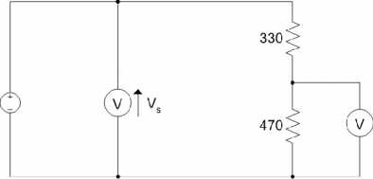

Figure 3.1: Simple voltage divider circuit.

Table 3.1: Measured voltage values of Figure 3.1.

Vs | V1 | V1/Vs(%)
1 V
5 V
10 V

Simple Current Divider:
- Connect up the circuit in Figure 3.2.
- Set the output current of the power supply by setting voltage and current limits close to zero (nearly fully anticlockwise). Adjust the voltage clockwise until Is is equal to the values given in Table 3.2.
- Measure I1 voltage and fill in Table 3.2.
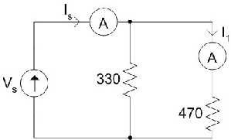
Figure 3.2: Simple current divider circuit.

Table 3.2: Calculated and measured current values of Figure 3.2.

Is | I1 Calculated | I1 Measured
10 mA
20 mA
30 mA

EXPERIMENT 4

DC CIRCUIT ANALYSIS

Aim:
Asdfa sdfasdf

Equipments:
- Adjustable Power Supply
- Two multimeters (measure current, voltage, resistance)
- Prototyping Board + Patch Wires
- Patch Leads
- Components:
o Resistors: 100, 220, 330, 470

Preliminary Work:
- The circuit given in Figure 4.1 is a DC circuit with single source voltage. Calculate the node and resistor voltage values that shown in Figure 4.1 and mentioned in Table 4.1. Fill in the results in Table 4.1
- The circuit given in Figure 4.2 is a DC circuit with multiple source voltages. Calculate the node and resistor voltage values that shown in Figure 4.2 and mentioned in Table
4.2. Fill in the results in Table 4.2

Experimental Procedure:

DC Circuit with Single Source
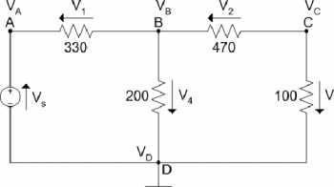
Connect up the circuit given in Figure 4.1. Measure the node and resistor voltage values and fill in the Table 4.1.
Figure 4.1: DC circuit with one source voltage.

Table 4.1: Calculated and measured voltage values of Figure 4.1.

Voltage | Calculated | Measured
Vs | 5.0
V1
V2
V3
V4
VA
VB
VC

DC Circuit with Multiple Source
Connect up the circuit given in Figure 4.2. Measure the node and resistor voltage values and fill in the Table 4.2.
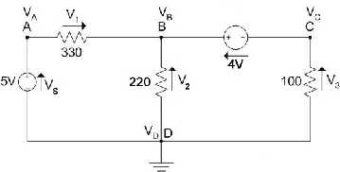
Figure 4.2: DC circuit with multiple source voltage

Table 4.2: Calculated and measured voltage values of Figure 4.2.

Voltage | Calculated | Measured
V1
V2
V3
VA
VB
VC

EXPERIMENT 5

KIRCHHOFF’S VOLTAGE and CURRENT LAWS

Aim:
Verify Kirchhoff’s Voltage Law (KVL) and Kirchhoff’s Current Law (KCL) using mesh and nodal analysis of the given circuit.

Equipments:
- Adjustable Power Supply
- Two multimeters (measure current, voltage, resistance)
- Prototyping Board + Patch Wires
- Patch Leads
- Components:
o Resistors: 1 K (2), 1.2 K (2), 2.4 K

Explanation:

Kirchhoff’s Voltage Law:
Kirchhoff’s Voltage Law states that the algebraic sum of all the voltage around any closed path (loop or mesh) is zero.
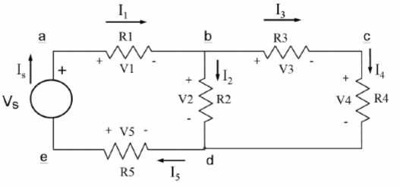
Applying Kirchhoff’s voltage law to the first and second loops in the circuit shown in Figure 5.1 yields:
Loop 1: − + + + = 0 (1)

Loop 2: − + + = 0 (2)

Figure 5.1: Circuit diagram used for Kirchhoff’s Voltage and Current Laws

zero

Kirchhoff’s Current Law:
Kirchhoff’s Voltage Law states that the algebraic sum of all the currents at any node is

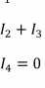
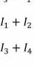
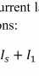
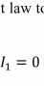
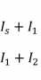
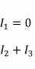
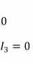
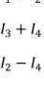
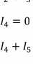
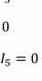
Applying Kirchhoff’s current law to the first four nodes in the circuit shown in Figure

  - yields the following equations:

Node a: | − | + | = 0 |  | (3)
Node b: | − | + | + | = 0 | (4)
Node c: | − | + | = 0 |  | (5)
Node d: | − | − | + | = 0 | (6)

Preliminary Work:
Theoretically calculate the voltages and currents for each element in the Figure 5.1.

Experimental Procedure:

Kirchhoff’s Voltage and Current Law
    - Connect up the circuit given in Figure 5.1. Use the resistor values as
R1 = 1 KΩ R2 = 2.4 KΩ R3 = 1.2 KΩ R4 = 1 KΩ R5 = 1.2 KΩ
    - Set the source voltage to 5 V and measure the arm current values and resistor voltage values and fill in the Table 5.1.

Table 5.1: Measured voltage, current and resistor values of Figure 5.1.

Branch Current /  Voltage | V (Volts) | I (mA) | R (KΩ)
V1, I1
V2, I2
V3, I3
V4, I4
V5, I5
Vs, Is

EXPERIMENT 6

THEVENIN EQUIVALENT CIRCUIT and MAXIMUM POWER TRANSFER

Aim:
Verify Thevenin’s theorem by obtaining the Thevenin equivalent voltage (VTH) and Thevenin equivalent resistance (RTH) for the given circuit. Verify the Maximum Power Transfer Theorem.

Equipments:
- Adjustable Power Supply
- Two multimeters (measure current, voltage, resistance)
- Prototyping Board + Patch Wires
- Patch Leads
- Components:
o Resistors: 300 Ω (2), 560 Ω (2), 820 Ω and 1.2 K Ω.

Explanation:

Thevenin’s Theorem:

It is a process by which a complex circuit is reduced to an equivalent series circuit consisting of a single voltage source (V ), a series resistance (R ) and a load resistance
TH TH

(R ). After creating the Thévenin Equivalent Circuit, the load voltage V
L L
may be easily determined.
or the load current I
L

One of the main uses of Thévenin’s theorem is the replacement of a large part of a circuit, often a complicated and uninteresting part, by a very simple equivalent. The new simpler circuit enables us to make rapid calculations of the voltage, current, and power which the original circuit is able to deliver to a load. It also helps us to choose the best value of this load resistance for maximum power transfer.
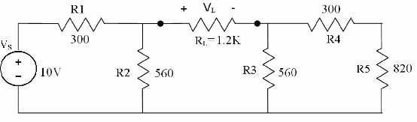
Figure 6.1: Circuit diagram used for Thevenin’s Theorem

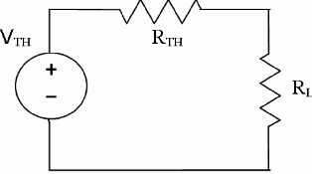

Figure 6.2: Thevenin Equivalent Circuit of Figure 6.1.

.

Maximum Power Transfer Theorem:

Maximum Power Transfer Theorem states that an independent voltage source in series with a resistance R or an independent current source in parallel with a resistance R ,
S S
delivers a maximum power to that load resistance R for which R = R
L L S.

In terms of a Thévenin Equivalent Circuit, maximum power is delivered to the load resistance R when R is equal to the Thévenin equivalent resistance R of the circuit.
L L TH
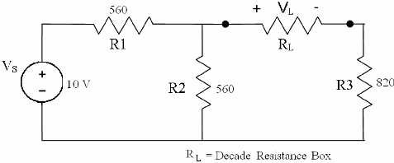

Figure 6.3: Maximum Power Transfer.

Preliminary Work:
- Theoretically find the Thevenin Equivalent Circuit in the Figure 6.1.
- Calculate the value of RL for which maximum power is transferred in Figure 6.3.

Experimental Procedure:
- Verifying the Thevenin Theorem
  - Connect up the circuit given in Figure 6.1. Find VTH: Remove the load resistance RL and measure the open circuit voltage VOC across the terminals. This is equal to VTH. See Figure 6.4. below .

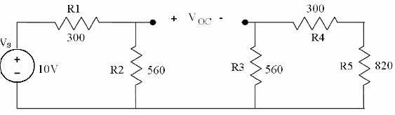
Figure 6.4:Measuring the Thevenin Voltage.

  - Find R : Remove the source voltage V and construct the circuit as in
TH S
Figure.6.5. below. Measure the resistance looking into the opening where R
L
was with an ohmmeter (DMM). This gives R . Make sure there is no power
TH
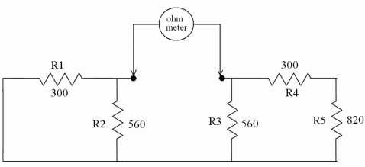
in the circuit before measuring with an Ohm-meter.
Figure 6.5: Measuring the Thevenin Resistance RTH.

- Verifying the Maximum Power Transfer theorem
  - Construct the circuit given in Figure 6.3. Use a potentiometer as RL.
  - Connect the multimeter across the RL for measuring the load voltage
  - To find the value of the RL for which maximum power is transferred, vary the resistance of the potentiometer between 800 Ω to 1400 Ω in 100 Ω steps and note down VL for each case.
  - Calculate the power for each load resistor value using

=

Then, find the resistor value corresponding to the maximum power.
  - Compare this resistance value with Thevenin Equivalent resistance value.

EXPERIMENT 7

NORTON’S THEOREM

Aim:
To verify Norton’s Theorem.

Equipments:
- Adjustable Power Supply
- Two multimeters (measure current, voltage, resistance)
- Prototyping Board + Patch Wires
- Patch Leads
- Components:
o Resistors: 2.2 kΩ (2), 3.3 kΩ (2), 4.7 kΩ and 1.0 k Ω.

Explanation:

Norton’s Theorem:

Norton’s theorem states that “Any two terminal bilateral linear d.c. circuit can be replaced by an equivalent circuit consisting of a current source and a parallel resistor”.
Any circuit having number of voltage source, resistor and open output can be replaced by a single equivalent circuit consisting of a single current source in parallel with a resistor, where the value of current source is equal to the short circuit current in the output terminals and the resistance is equal to the resistance seen into the network across the output terminals.
This theorem is possibly the most extensively used network theorem. It is applicable where it is desired to determine the current through or voltage across any one element in a network without going the rigorous of solving a set of network equations.
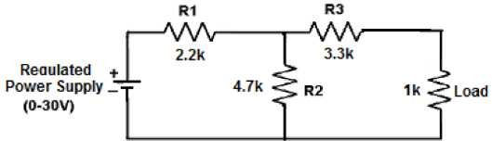

Figure 7.1: Circuit diagram used for Norton’s Theorem

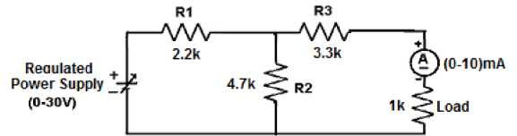

Preliminary Work:
Figure 7.2: Measurement of load current.

.

1. Theoretically find the Norton Equivalent Circuit in the Figure 7.1 and draw in the box.

Experimental Procedure:
- Connections are made as per the circuit diagram.
- The input voltage is adjusted to the given values
- Note down the current in the load resistance.
- The load terminal is short circuited and short circuited current (IN) is found in the load terminals.
- The source is open circuited (current source) or short circuited (Voltage source) and thevenin’s resistance is measured across the load terminals.
- Draw the Norton’s equivalent circuit.
- Calculate the current through the load resistance and compare the value with observed value.

EXPERIMENT 8

SUPERPOSITION THEOREM

Aim:
Verify superposition theorems.

Equipments:
- Adjustable Power Supply
- Two multimeters (measure current, voltage, resistance)
- Prototyping Board + Patch Wires
- Patch Leads
- Components:
o Resistors: 3.3 kΩ (2), 5.6 kΩ and 1.0 k Ω.

Explanation:

Superposition Theorem:

It states that the response in a linear circuit with multiple sources can be obtained by adding the individual responses caused by the separate independent sources acting alone.
For an independent source acting alone, all other independent voltage sources are replaced by short circuits and all other independent current sources are replaced by open circuits.
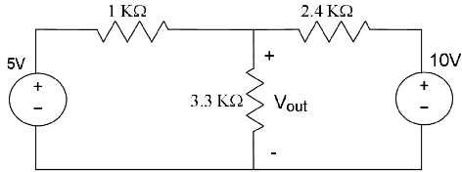

Figure 8.1: Circuit diagram used for Superposition Theorem..

Preliminary Work:
- Theoretically find the Superposition Theorem in the Figure 8.1.

Experimental Procedure:

- Construct the circuit given in Figure 8.1.

- Measure and record the voltage across the 3.3 kΩ.
EXPERIMENT 9

DC RC CIRCUIT

Aim:
Reading about capacitors, capacitors in series and parallel, RC circuits, and energy stored in capacitors.

Equipments:
- 1 protoboard
- 1 multimeter (measure current, voltage, resistance)
- Prototyping Board + Patch Wires
- Patch Leads
- Components:
- 0.1μF capacitor
- 0.5μF capacitor
- 1μF capacitor
- 22 Mohm or larger resistor
- stopwatch

Explanation:

The Time Constant
All Electrical or Electronic circuits or systems suffer from some form of "time-delay" between its input and output, when a signal or voltage, either continuous, (DC) or alternating (AC) is firstly applied to it. This delay is generally known as the time delay or Time Constant of the circuit and it is the time response of the circuit when a step voltage or signal is firstly applied. The resultant time constant of any circuit or system will mainly depend upon the reactive components either capacitive or inductive connected to it and is a measurement of the response time with units of, Tau - τ
When an increasing DC voltage is applied to a discharged Capacitor the capacitor draws a charging current and "charges up", and when the voltage is reduced, the capacitor discharges in the opposite direction. Because capacitors are able to store electrical energy they act like small batteries and can store or release the energy as required. The charge on the plates of the capacitor is given as: Q = CV. This charging (storage) and discharging (release) of a capacitors energy is never instant but takes a certain amount of time to occur with the time taken for the capacitor to charge or discharge to within a certain percentage of its maximum supply value being known as its Time Constant (τ).
If a resistor is connected in series with the capacitor forming an RC circuit, the capacitor will charge up gradually through the resistor until the voltage across the capacitor

reaches that of the supply voltage. The time called the transient response, required for this to occur is equivalent to about 5 time constants or 5T. This transient response time T, is measured in terms of τ = R x C, in seconds, where R is the value of the resistor in ohms and C is the value of the capacitor in Farads. This then forms the basis of an RC charging circuit were 5T can also be thought of as "5 x RC".

RC Charging Circuit
The figure below shows a capacitor, (C) in series with a resistor, (R) forming a RC Charging Circuit connected across a DC battery supply (Vs) via a mechanical switch. When the switch is closed, the capacitor will gradually charge up through the resistor until the voltage across it reaches the supply voltage of the battery. The manner in which the capacitor charges up is also shown below.
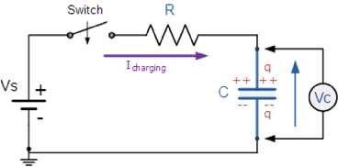
Figure 9.1: RC Charging Circuit

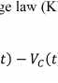
Let us assume above, that the capacitor, C is fully "discharged" and the switch (S) is fully open. These are the initial conditions of the circuit, then t = 0, i = 0 and q = 0. When the switch is closed the time begins at t = 0 and current begins to flow into the capacitor via the resistor. Since the initial voltage across the capacitor is zero, (Vc = 0) the capacitor appears to be a short circuit and the maximum current flows through the circuit restricted only by the resistor R. Then by using Kirchhoff’s voltage law (KVL), the voltage drops around the circuit are given as:
− ( ) − ( ) = 0

The current no flowing around the circuit is called the Charging Current and is found by using Ohms law as: i = VR/R.

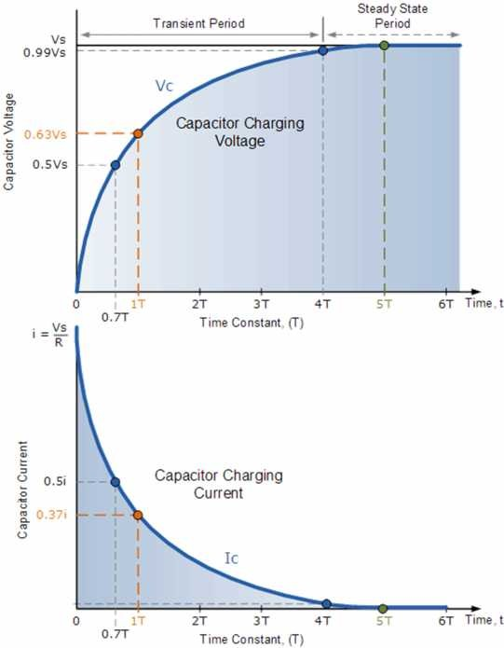
RC Charging Curves
Figure 9.2: RC Charging Curves

The capacitor now starts to charge up as shown, with the rise in the RC charging curve steeper at the beginning because the charging rate is fastest at the start and then tapers off as the capacitor takes on additional charge at a slower rate. As the capacitor charges the potential difference across its plates increases with the actual time taken for the charge on the capacitor to reach 63% of its maximum possible voltage, in our curve 0.63Vs being known as the Time Constant, (T) of the circuit and is given the abbreviation of 1T. As the capacitor charges up, the voltage difference between Vs and Vc reduces, so to does the circuit current, i. Then at the final condition, t = ∞, i = 0, q = Q = CV. Then at infinity the current diminishes to zero, the

capacitor acts like an open circuit condition therefore, the voltage drop is entirely across the capacitor.
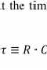
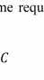
So mathematically we can say that the time required for a capacitor to charge up to one time constant is given as:

≡ ∙

Where, R is in Ω's and C in Farads.

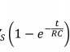
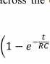
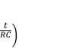
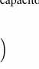
Since voltage V is related to charge on a capacitor given by the equation, Vc = Q/C, the voltage across the value of the voltage across the capacitor, (Vc) at any instant in time during the charging period is given as:

= 1 −

Where:

Vc is the voltage across the capacitor Vs is the supply voltage
t is the elapsed time since the application of the supply voltage RC is the time constant of the RC charging circuit

After a period equivalent to 4 time constants, (4T) the capacitor in this RC charging circuit is virtually fully charged and the voltage across the capacitor is now approx 99% of its maximum value, 0.99Vs. The time period taken for the capacitor to reach this 4T point is known as the Transient Period. After a time of 5T the capacitor is now fully charged and the voltage across the capacitor, (VC) is equal to the supply voltage, (Vs). As the capacitor is fully charged no more current flows in the circuit. The time period after this 5T point is known as the Steady State Period.
As the voltage across the capacitor Vc changes with time, and is a different value at each time constant up to 5T, we can calculate this value of capacitor voltage, Vc at any given point, for example.

Preliminary Work:
Calculate the time constant of the following circuit.
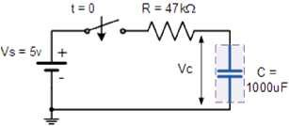
Figure 9.3: RC Circuit

- What value will be the voltage across the capacitor at 0.7 time constants?
- How long will it take to "fully charge" the capacitor?

Experimental Procedure:
- Use the impedance bridge to measure the capacitance of the capacitors. Use the DMM to measure the resistance of the resistors.
- Record the power supply voltage. This will also be the voltage across the capacitor when it is fully charged (Vc at t=0).
- Wire the circuit in Figure 9.4. Record the meter voltage. This is Vm at t=0.
- Disconnect the power supply and record Vm at 4 second intervals until the voltage drops to just below 0.5 VDC. One person in the group should watch the time and another should record the voltages. Do a practice run without writing data to get an idea of how many voltages you will need to record. This number will vary for each set of capacitors.
- Do this three times, one for the 0.5μF capacitor alone, one for the 0.5μF and the 1μF capacitors in series, and once for the 0.1μF and the 0.5μF capacitors in parallel.

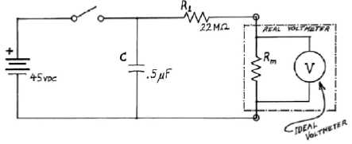
Figure 9.4: Circuit diagram of experiment 9.

